**PMSM Lab**

**Name:Li Xin**

**ITMO ID:375334**

**HDU ID:22320404**

**TASK 1.BUILD THE MECHANICAL PART OF THE MODEL BASED ON DIFFERENTIAL EQUATIONS**

**1.DATA INITIAL**





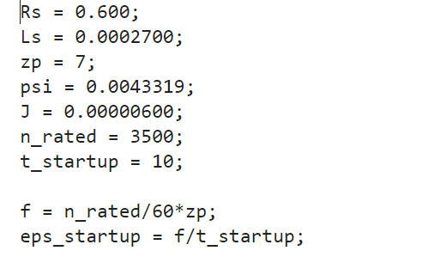

**2.MODEL CONFIGURATION**

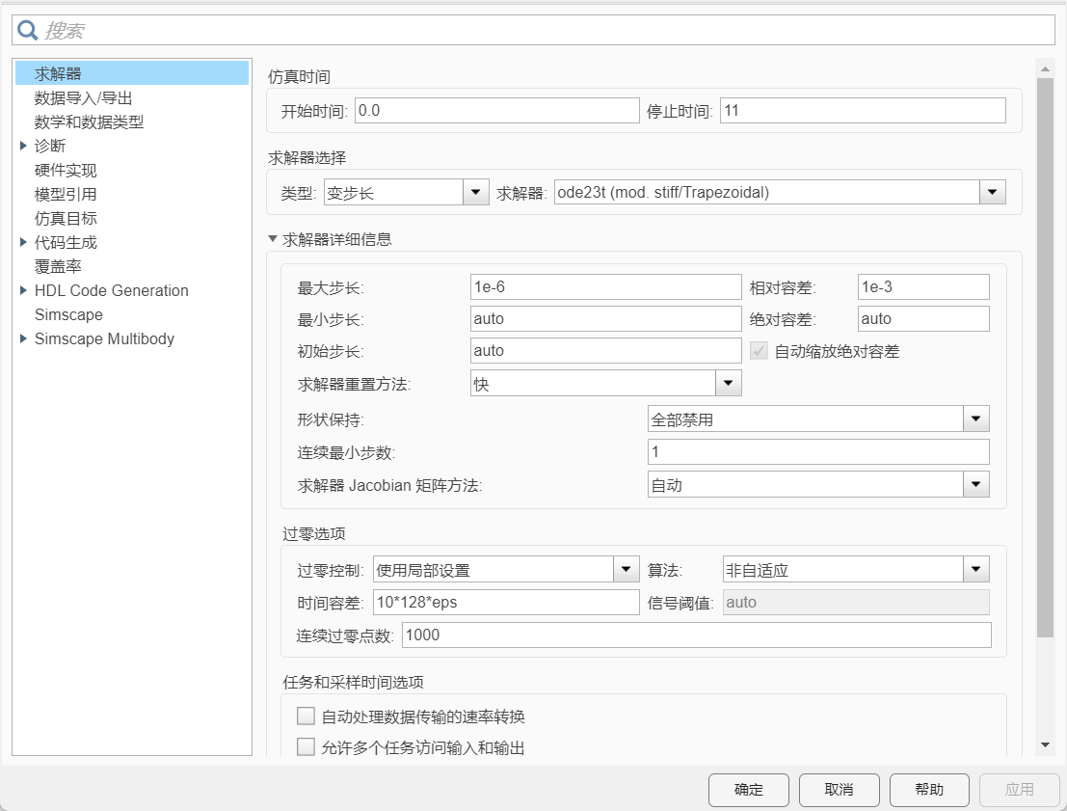

1. **The model of SPMSM based on differential equations**

**Block diagram of d-q equations**

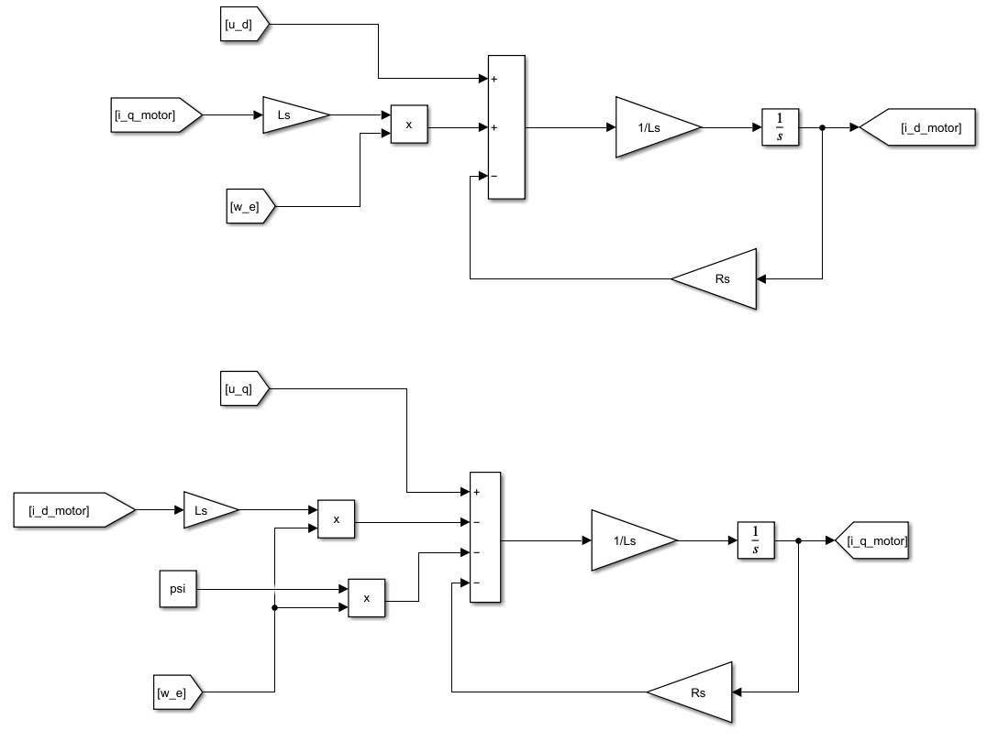

**Input Clark & Park transformation:**

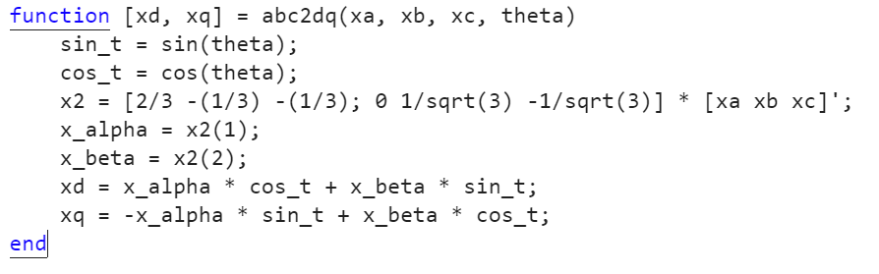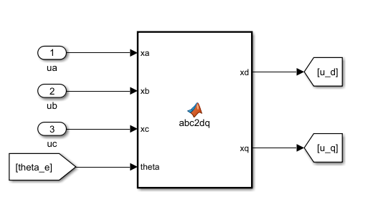

**Output inverse Park & Clark transformation:**

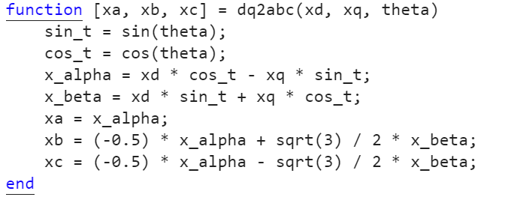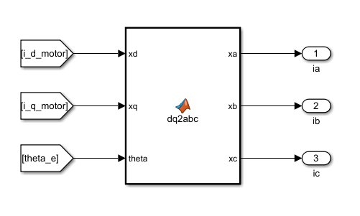

**Mechanical part:**

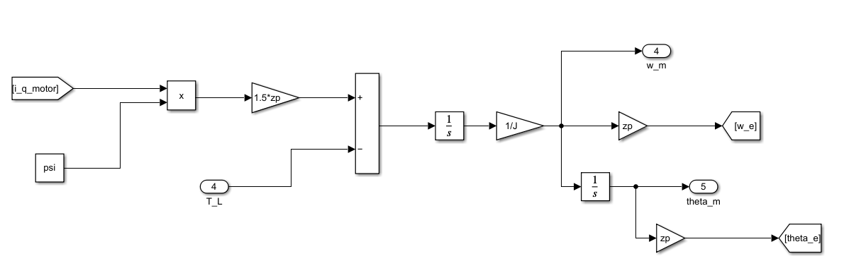

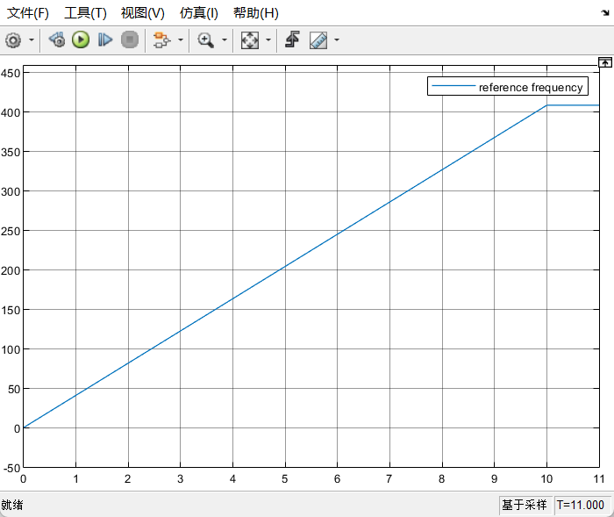

1-reference frequency

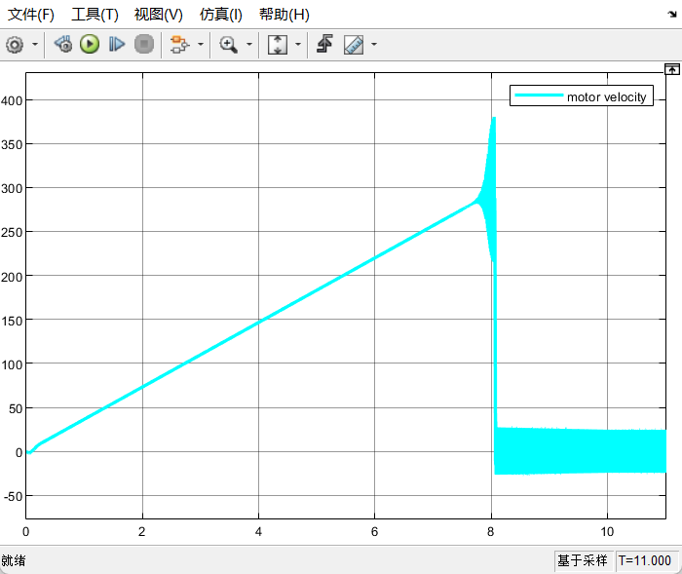

2- motor velocity in rev/min

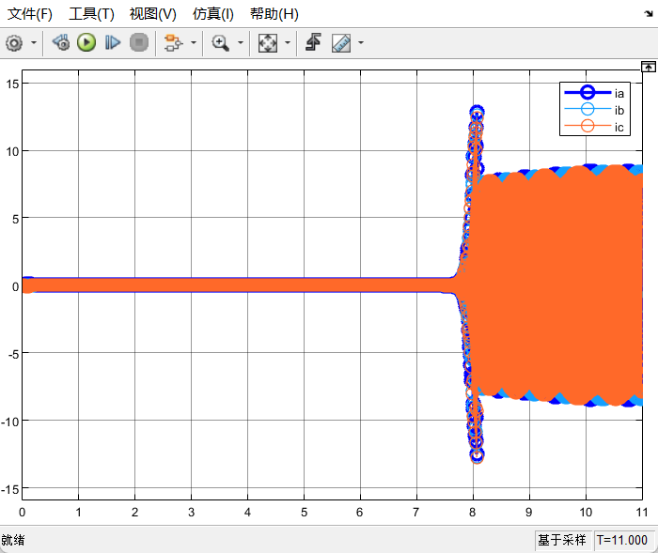

3-phase currents ia, ib, ic,

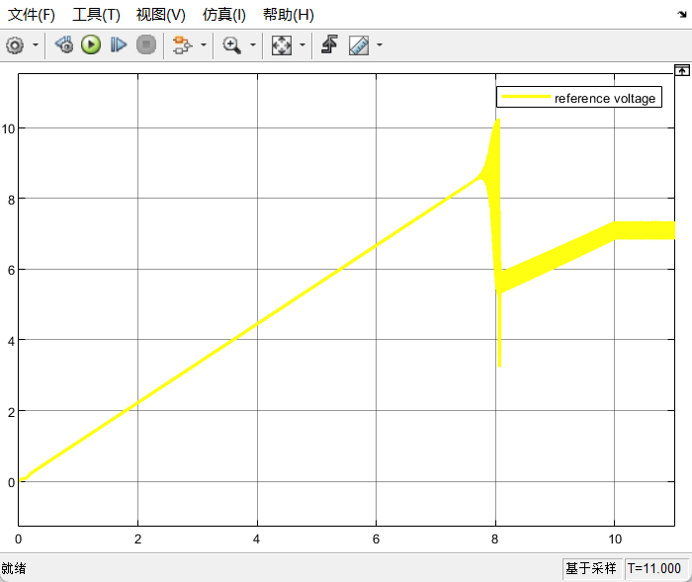

4-reference voltage vs*, V

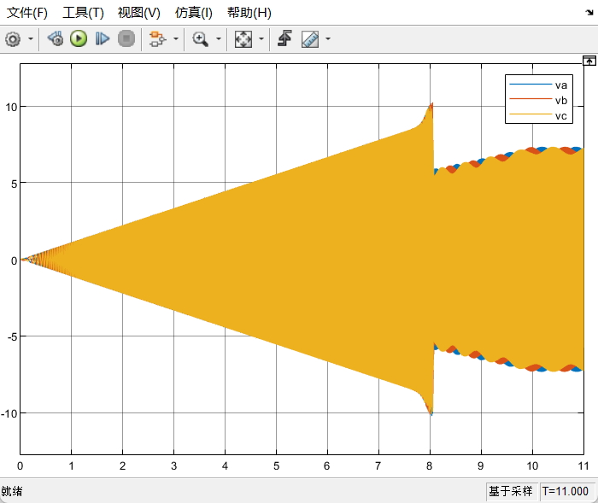

1. phase voltages va, vb, vc, V

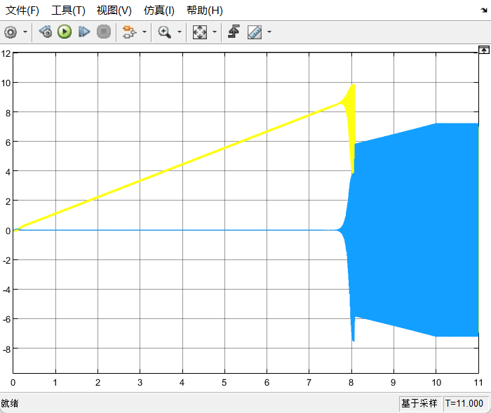

6-dq-voltages, V

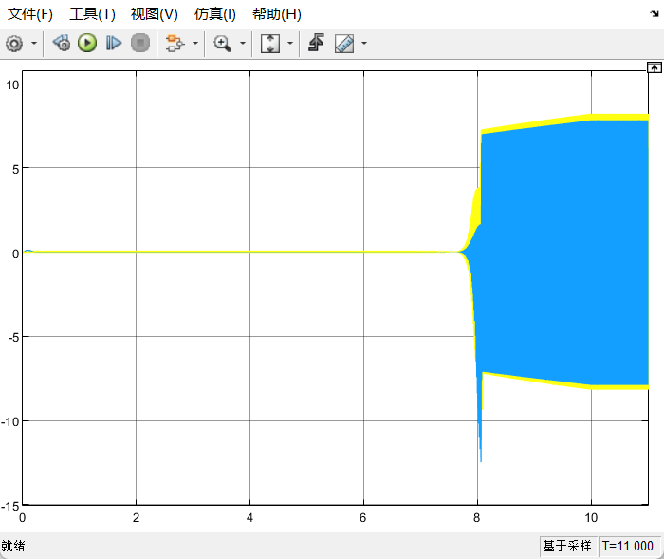

7-dq-currents, A

**TASK 2.BUILD THE MECHANICAL PART OF THE MODEL BASED ON SIMSCAPE MODEL**

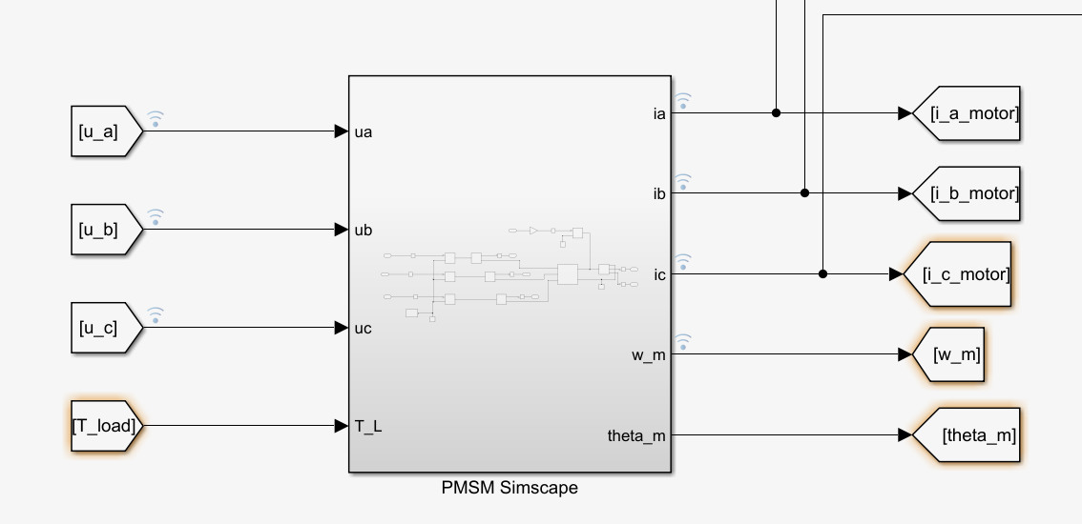

**1.Model build**

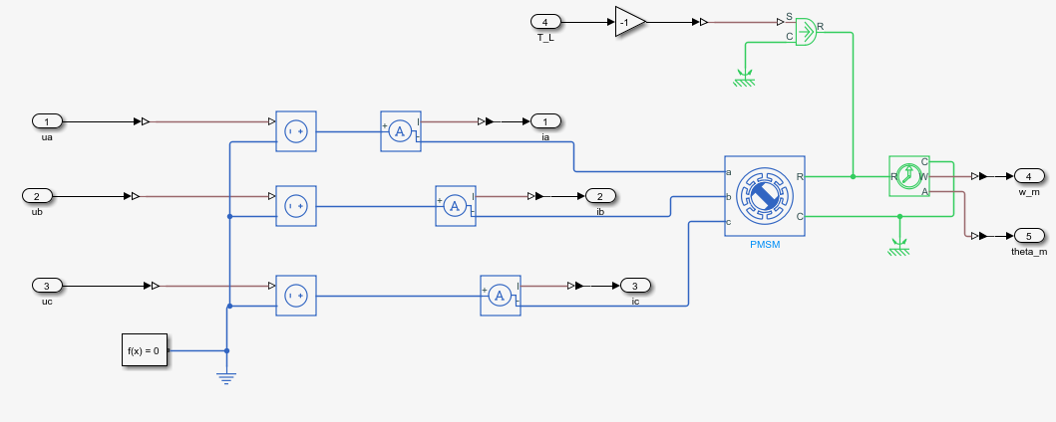

**2.Motor parameters setting**

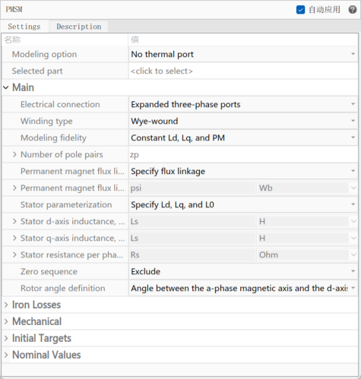

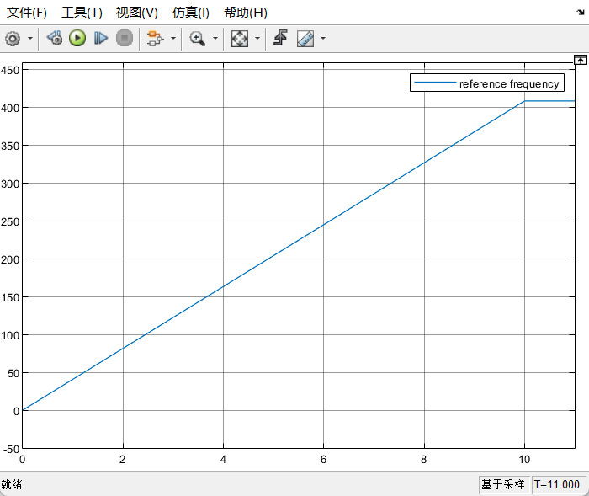

**1-reference frequency**

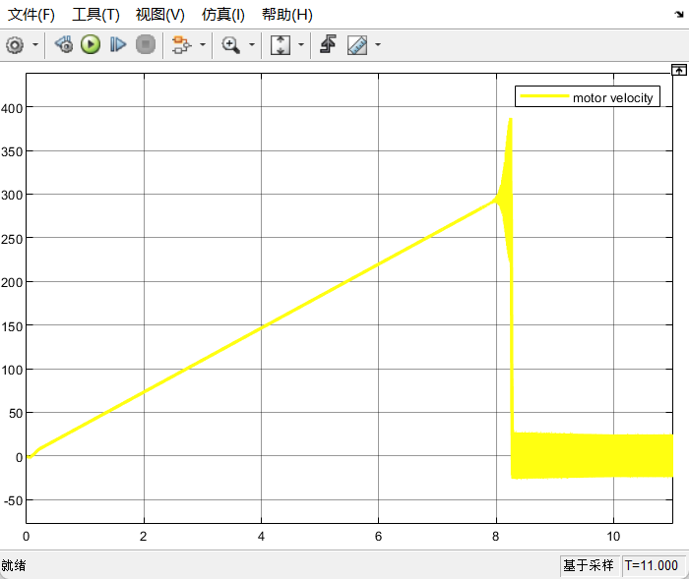

**2-motor velocity in rev/min**

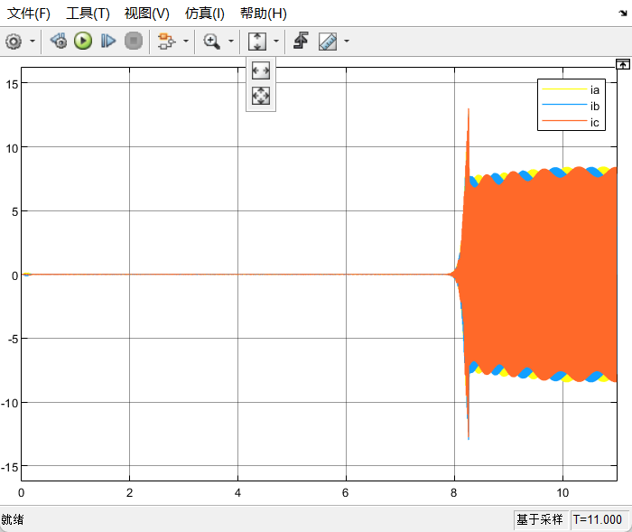

**3--phase currents ia, ib, ic, A**

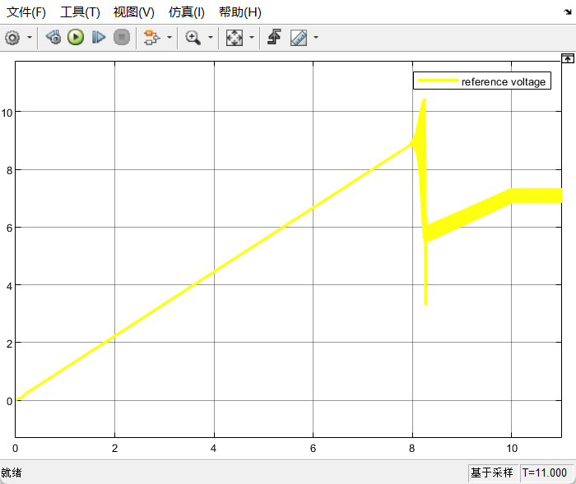

**4-reference voltage vs*,V**

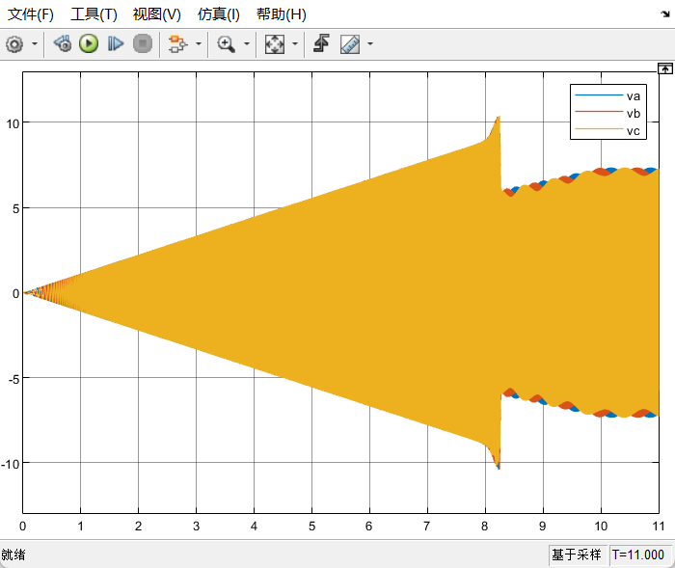

**5-phase voltages va, vb, vc, V**

**Conclusion:**

The lab examined two distinct methods for modeling motor behavior: one using differential equations in the d/q reference frame and the other utilizing Simscape.

Both approaches considered the motor's electrical and mechanical dynamics to evaluate its performance. The experiment concluded with a voltage control strategy, specifically the V/f startup method, to regulate motor speed. Simulations of no-load startup were run for both models, and the results showed similar behavior. However, the V/f controller was unable to drive the motor to its rated speed. After about 8 seconds, oscillations appeared in both the reference voltage and motor speed, signaling a loss of synchronization. As the slip increased, the motor speed dropped toward zero and continued oscillating, never achieving the rated rotational speed.